Local Store Discounts
Focus Setup

- To access and setup a local store discount in Focus go to Setup > Order Entry > Discounts
  - This will get you to the Discounts section in Focus
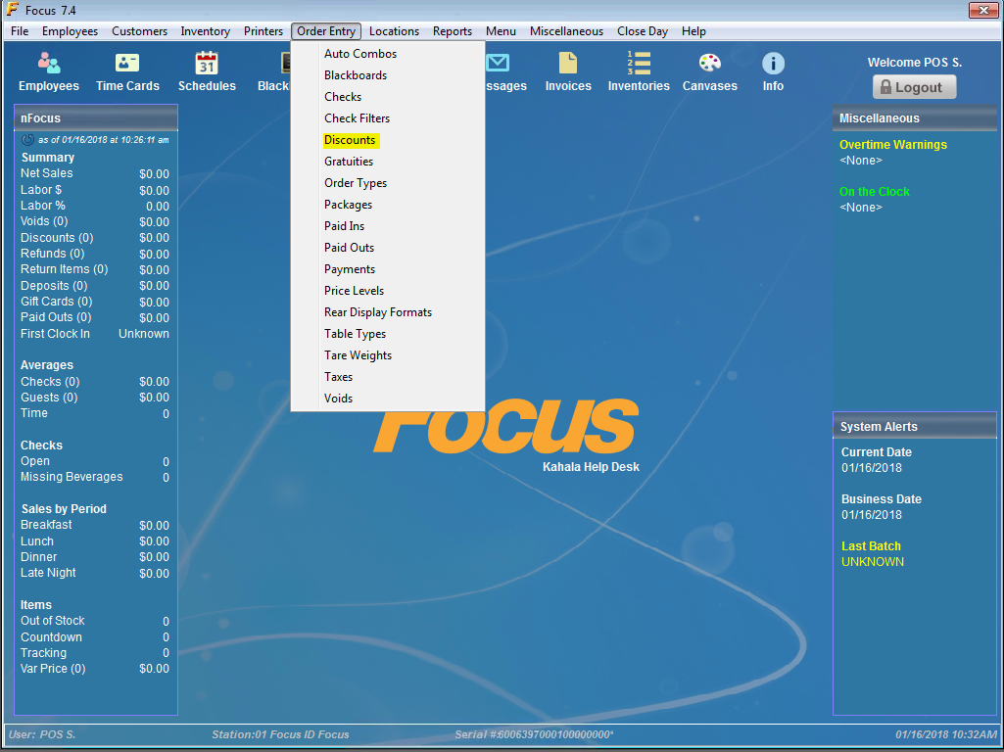
- From here you will need to scroll down to Discount PLU #50
  - #50-99 will be used for the local store discounts in Focus
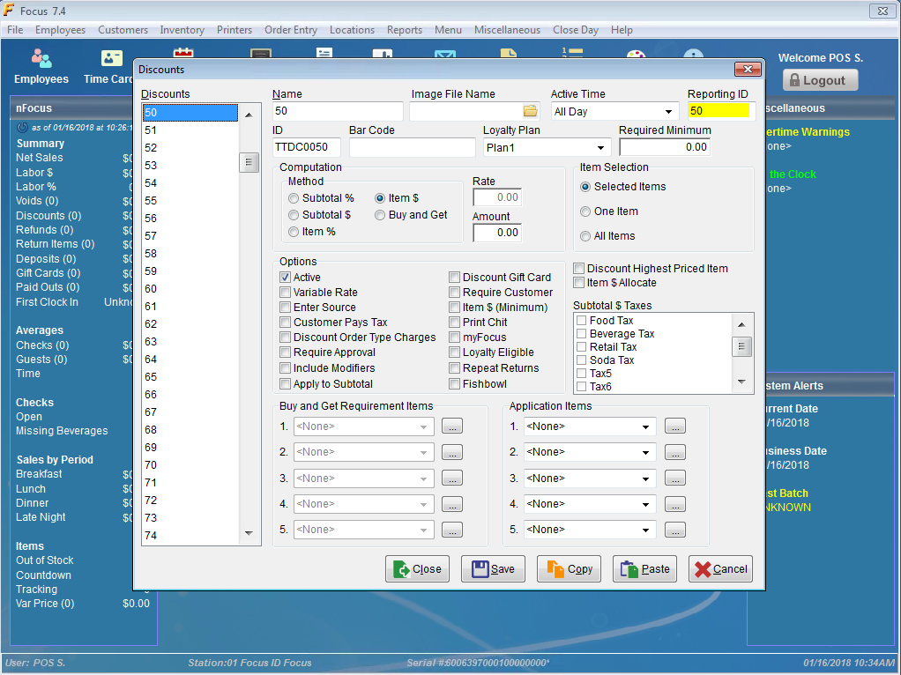
- The next step will be to name the discount based on the local offer
  - You will use the name field to enter the name of the local discount
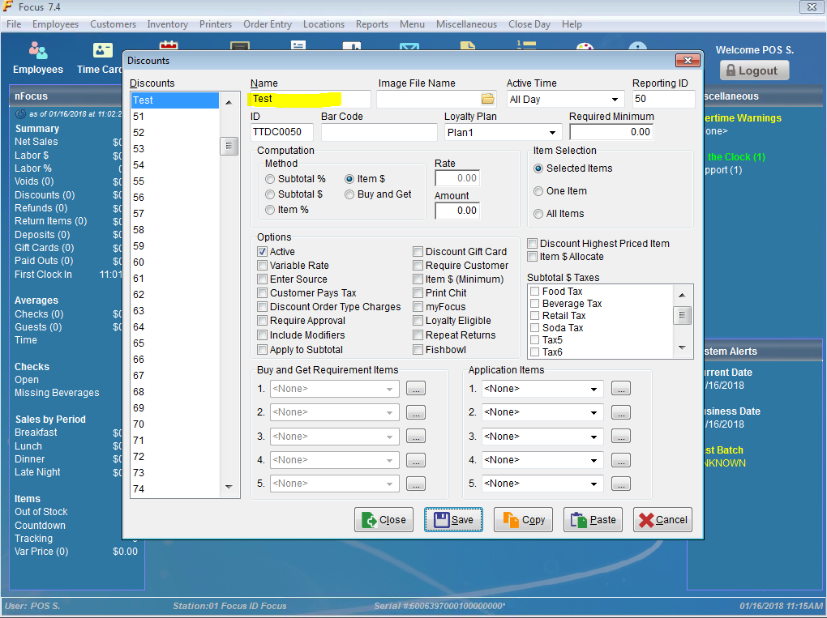
- The Reporting ID will be the PLU #(50-99) that will be used to ring in the discount
  - You do not need to change this number
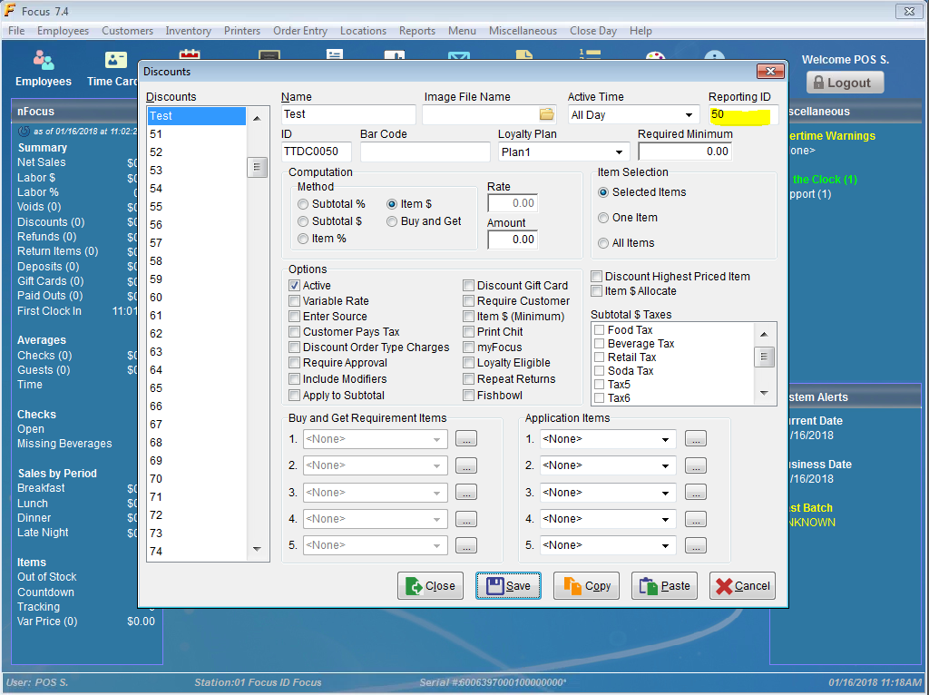

- The next step is to change the amount of the discount
  - You will need to enter the amount the discount I taking off for that PLU #
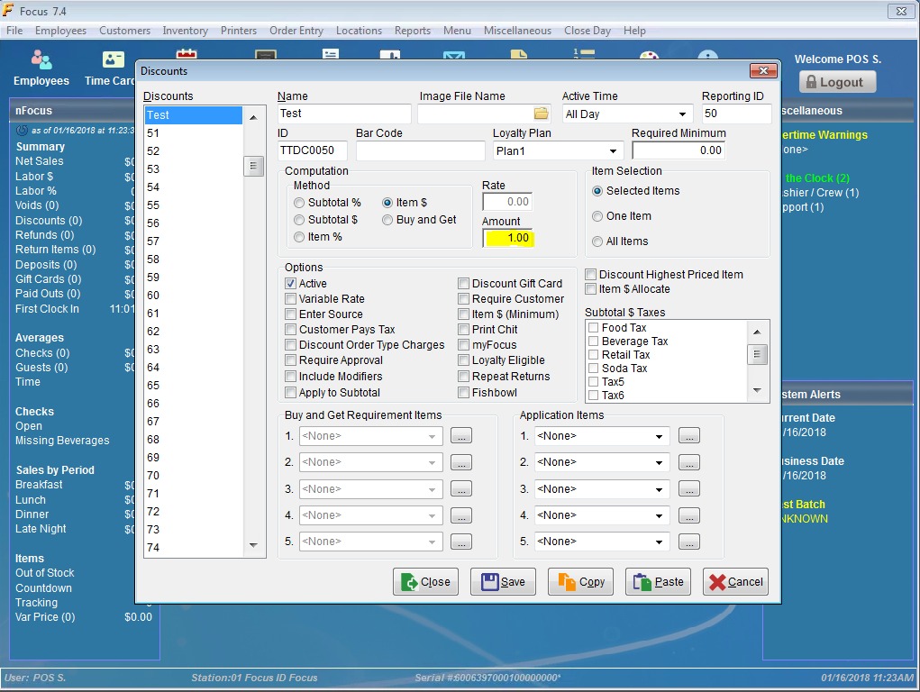
- Press Save to save your changes to the local store discount
Enter Discount PLU #(50-99)
- Log in using your Focus Access code from the Main Focus screen
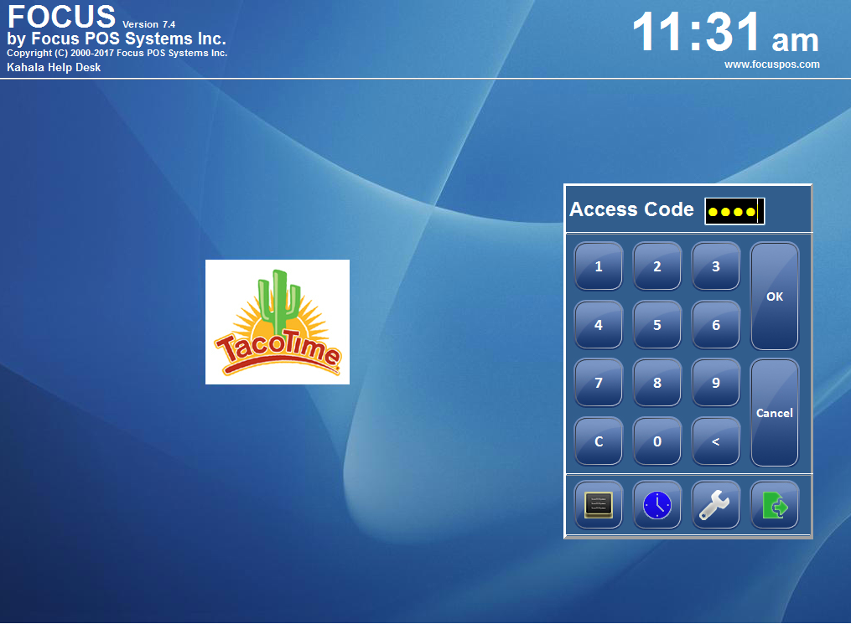
- You will then ring in any items as normal
  - To apply a local store discount, select the Discount ID Lookup button
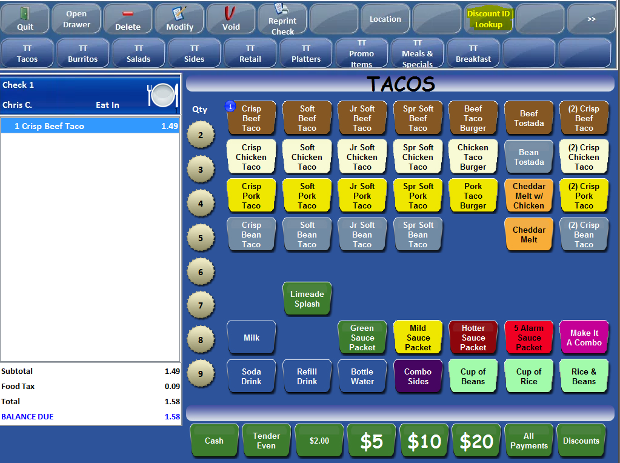
- Here you will enter the local discount PLU #(50-99)
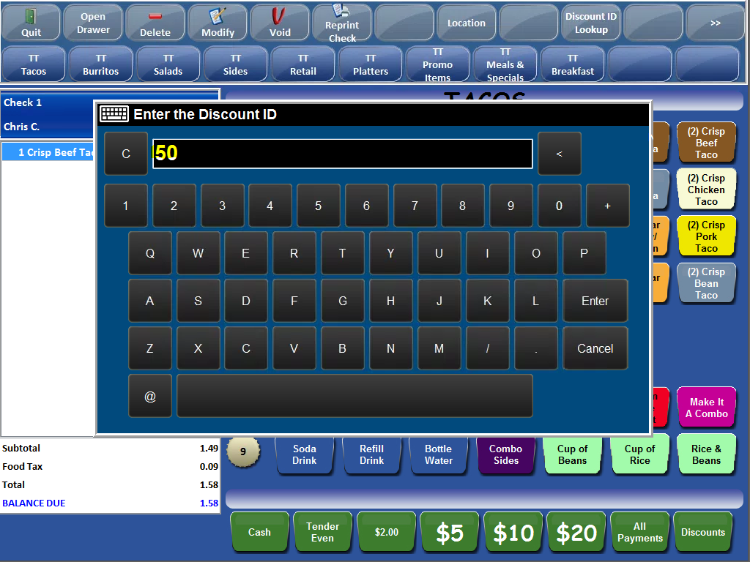

- This will apply the local store discount
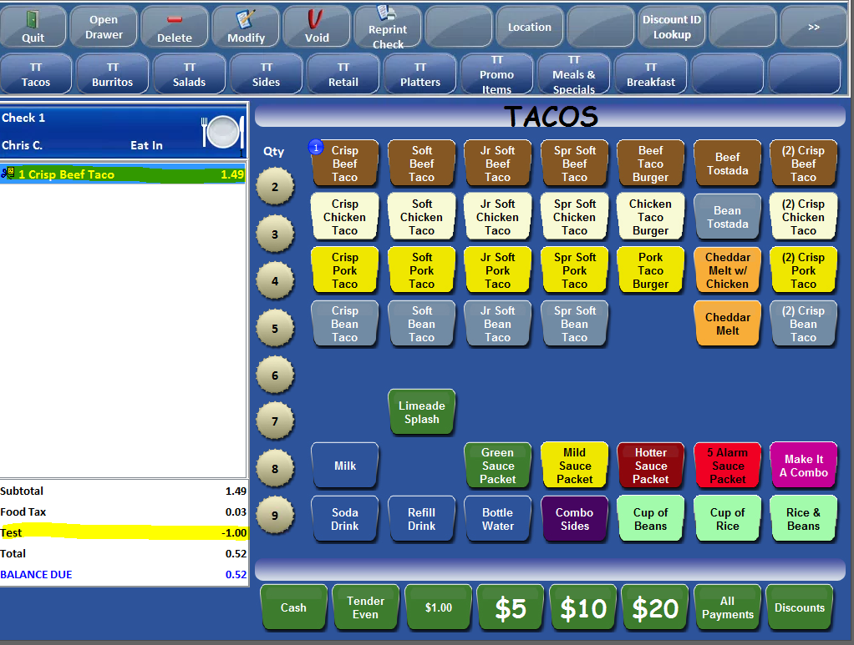
- You can also access the Local Store Discount PLU #(50-99) by selecting the TT Local Discounts Canvas
